**Foraging traits predict stage-structured feeding by freshwater fishes**

Running head: Stage-structured feeding by freshwater fishes

Abraham J. Kanz1,2 and Jeff S. Wesner1

1Department of Biology, University of South Dakota, Vermillion, South Dakota

2Present Address:

The Department of Natural Resource Ecology & Management

Oklahoma State University

474-B Agricultural Hall

Stillwater, OK 74078

Corresponding Author: [abraham.kanz@okstate.edu](mailto:abraham.kanz@okstate.edu)

Keywords: Stage-structured feeding, food webs, freshwater, aquatic insects, fish

**Abstract**

Fish are often top predators in freshwater ecosystems, yet a substantial proportion of their prey can come from non-aquatic sources (e.g., terrestrial subsidies). The importance of subsidies is tied to fish foraging domain and behavior. These fish traits (e.g., propensity for surface feeding), may also alter fish consumption of the remaining fraction of aquatic prey, such as the life-stages of consumed aquatic insects. Since aquatic insects may alter their feeding at later developmental stages (i.e. pupal and adult chironomids), their consumption at differing life stages may have ecological relevance. We hypothesized that fish foraging domain –  vertical microhabitat used for feeding – would be associated with fraction of non-consumer life-stages of terrestrial and aquatic prey that are consumed. Fish diets (n=606 diet samples, 22 species) were collected from two backwater and two stream sites weekly over two months of one summer. Consumption of adult and pupal prey within individual species ranged from ~1% to 44% of total dry mass. These results indicate stage-structured feeding occurs in freshwater food webs and varies by species.

**Introduction**

Despite the near ubiquity of fish-insect interactions in freshwater food webs, evidence for consistent top-down control of invertebrates by fish is mixed (Matthews 1998, Dahl and Greenberg 1996, Wesner 2019).A proposed explanation for mixed effects of fish predation is that some fishes feed more heavily on drift and/or are subsidized by terrestrial prey, thereby reducing direct consumption of benthic invertebrates (Garman 1991, Nakano et al. 1999, Baxter et al. 2004, Pusey and Arthington 2003). Propensity for drift feeding or terrestrial feeding may also be associated with fish feeding traits, such as morphological or behavioral adaptations for benthic-feeding versus feeding at the surface or middle of the water column (Dahl and Greenberg 1996, Wagner et al. 2012, Ross 2013). A complementary, but less well-studied, explanation for weak effects of some fishes is that they may also target later-developing stages of aquatic insects, such as pupae (Wagner et al. 2012, Warmbold and Wesner 2018). Preferential consumption of insect pupae and adults may be ecologically important because some pupal and adult insects (i.e. chironomids which we focused on for this study) are functionally identical to terrestrial insects in the sense that both life stages have stopped feeding and are no longer consumers in aquatic food webs (Figure 1). Not only may this help to explain the consistently strong effects of fishes on emerging aquatic insects, even when effects on larval insect densities are weak (Warmbold and Wesner 2018), but it is also likely to go undetected in many diet studies. For example, isotopes change little across insect life stages (Kraus et al. 2014), so it is not possible to quantify stage-specific feeding in fish diets with stable isotopes, nor is it possible if prey are only categorized taxonomically.

We refer to this type of feeding as stage-structured predation, in which predators target different life-stages of the same prey species (De Roos et al. 2008, Miller and Rudolph 2011). While ecologists have been aware of stage-structured feeding within food webs for decades (Hardy 1924, Hutchinson 1959, Werner and Gilliam 1984, Werner 1984), it is often disregarded in classical ecological theory (Bolnick et al 2011, Violle et al 2012, Nilsson et al 2018). Yet stage-structured feeding can explain important ecological phenomena such as coexistence of predators on shared prey taxa (De Roos et al. 2008), biomass overcompensation (Miller and Rudolph 2011), and regulation of aquatic-terrestrial subsidies (Wesner 2017, Clegg et al. 2018).

The goal of this study was to quantify natural variation in terrestrial and stage-structured feeding by fishes. In particular, we measured the fraction of total insect prey in fish diets that was eaten as larval, pupal, or adult life-stages (Figure 1). We hypothesized that all fractions would be substantial, but that some species would show preference for consumption of pupal and adult prey while others would be more likely to primarily access larval prey.

**Sampling Methods**

Four sites, two backwaters and two sites within one stream, were sampled during the summer for this study. Sites were chosen to increase the breadth of fish species sampled. The backwater sites were connected to the main channel of the Missouri River. The two backwater sites were Burbank beach (latitude: 42°40'11.88"N, longitude: 96°47'22.82"W) and Gunderson backwater (latitude: 42°44'56.56"N, longitude: 96°57'12.08"W). Stream sites were at different locations along the same ephemeral stream system, a first order tributary of the Vermillion River called Spirit Mound Creek, with a width less than 3m and a depth of ~1m (fluctuating with precipitation). The stream sites were upstream (latitude: 42°52'4.29"N, longitude: 96°57'16.25"W) and downstream (latitude: 42°51'7.39"N, longitude: 96°56'39.28"W) within the same stream system. All sites are in SE South Dakota, USA.

Weekly diet sampling of fish was conducted in the mornings (between 6 am and 12 pm) at each of the four study sites starting on June 6, 2019 and ending on July 25, 2019. First, fish were collected via seine net and put into a 5-gallon bucket containing fresh water. To ensure that we sampled a variety of fishes, various seining techniques were used at each site, including kick-seining for benthic fishes, seining around vegetation, short seine-hauls, and long seine-hauls. Fish were then identified and moved from the holding tank to the anesthetizing tank (a 5-gallon bucket containing water and a dilute MS-222 solution). Once the fish were immobilized by the MS-222 solution, they were measured for standard length and gut contents were extracted with gastric lavage (Kamler and Pope 2001). To do this, a garden sprayer (acting as a pump for this procedure) with an appropriately sized tube for the mouth of the fish (≥ 3.2 mm inner diameter) was fed into the gut. Water was then pumped through the gut of the fish and any dislodged stomach contents were collected in a 250 µm sieve and preserved in 95% ethanol. The fish was then placed into a recovery tank (a 5-gallon bucket containing fresh water) and monitored for recovery. Fish were then released. Fish species and the number of individuals sampled are summarized in Table 1.

Prey items from the diet samples were identified to family or order and life stage using Merritt et al. (2008). Prey were further classified as aquatic or terrestrial (based on their larval habitat) and as either a consumer or non-consumer, indicating their trophic status in aquatic food webs. Pupae and adult stages of aquatic insects along with all terrestrial insects were classified as non-consumers, while aquatic larvae were classified as consumers. All prey in a sample were enumerated and a subset (up to 10 individuals per sample) was estimated for dry mass (mg) using length-mass regressions (Benke et al. 1999). For taxa that were not whole specimens, we were unable to measure lengths. In those cases, we used mass estimates from whole specimens obtained from different studies in the same region and estimated from a distribution (Warmbold 2016, Wesner et al. 2020). We then multiplied the mean individual dry mass of each prey taxon by the number of individuals in a sample to generate an estimate of sample dry mass.

Emergence was sampled at each site to determine whether stage-structured feeding varied as a function of insect emergence. During peak emergence events, the number of pupal and adult chironomids available for consumption increases. For this reason, we would expect consumption of adult and pupal insects to also increase. Three emergence traps were deployed at each site consisting of a 0.6m X 0.6m floating, pyramidal frame and a mesh covering (Cadmus et al. 2016). Emergence samples were collected from these in the morning twice per week, following 3-4 nights of deployment. Samples were frozen upon collection and identified to family or order using Merritt et al. (2008). Emergence estimates from these traps were averaged over the number of days they were deployed (3 or 4 days).

**Analysis**

To determine whether the proportion of each prey stage in diets varied across fish species, we fit a generalized linear mixed model with prey mass per stomach (mg dry mass) as the response variable, date, fish species, and prey stage, and all of their interactions as the predictor variables, and site as a random intercept. We used a Gamma likelihood with a log link, since prey mass is a positive, continuous measure.

For the model above, we used prey mass per fish, rather than prey mass per fish length (e.g., corrected for fish size), because there was no evidence that larger fish had a higher mass of prey (Figure S1). We used the posterior distribution of each model to estimate derived quantities of both total prey mass per fishand the proportion of prey that were eaten at each life stage for each fish species

To determine whether fish ate non-consumer life stages more often during periods of high insect emergence, we first modeled aquatic insect emergence (number/day/m2) as the response variable and date, site, and their interaction as the predictor variables. We used a generalized linear model with a Gamma likelihood and a log link. We then used the posterior median estimate of emergence from this model on each date at each site as the predictor variable in a second model. The second model used the raw proportion of non-consumer prey (aquatic origin only) as the response variable, median emergence, fish domain, and their interaction as the predictor variables, and site and fish species as random intercepts. Because proportions were continuous values between 0 and 1, this model had a beta likelihood with a logit-link.

Finally, we re-ran each of the models above using only the chironomid portions of prey mass or emergence (excluding the prey origin parameter, since chironomids are aquatic). This allowed us to determine whether our results were impacted by the lack of life-stage information available for some taxa in the complete dataset, since chironomids are relatively easy to differentiate by life stage (larva, pupa, adult) and hence feeding stage (larvae feed in aquatic food webs, pupae and adults do not).

Models were specified in R (version 3.4.2, Core Team R, 2017) using Bayesian inference with the *brms* package (Bürkner, 2017). Posterior distributions were generated with a Hamiltonian Monte Carlo algorithm through *rstan* (Stan Development Team, 2016). Prior distributions are described and justified (along with prior sensitivity analyses) in the Supplementary Information (Figures S2-4). All code and data can be found at: https://github.com/Abrahamkanz/stageguildms

**Results**

*Fish Sampled*

We collected a total of 606 diet samples from 22 fish species (Table 1). Creek Chub (*Semotilus atromaculatus*) was the most commonly sampled fish (n = 95 samples), followed by Johnny Darter (*Etheostoma nigrum*, n = 74), and Smallmouth Buffalo (*Ictiobus cyprinellus*, n = 73).

*Prey composition*

Among the 59 prey taxa in fish diets, chironomids made up 64% of all diet items by abundance, 45% by biomass, and occurred in 438/617 fish stomachs (71%). The next most common item was Branchiopods (14% by abundance, 4% by biomass, 24% by occurrence). All other prey taxa made up less than 4% of diets by abundance, biomass or occurrence. One exception was crayfish chelipods, which made up less than 4% of abundance or occurrence, but 23% of biomass due to their large size (Figure S5). They were found in 24/606 fish stomachs.

*Terrestrial and stage-structured feeding*

Fish had a similar amount of prey mass in their stomachs, regardless of species, averaging 21 ± 11 mg DM per fish (Figure 2a; posterior median ± sd). This amount varied little between fish foraging domains (Figure 2a) or over time (Figure 3a). However, the proportion of chironomids in each life stage differed among fish species. For intermediate and surface-feeding fishes, 12 to 14% of their diets were terrestrial with averages exceeding 20% for four species (Figure 2b). In comparison, terrestrial prey made up only 3 ± 1% for benthic-feeding fishes (Figure 2b), with a >99% probability that intermediate and surface-feeding fish had a higher fraction of terrestrial prey than benthic fish. These differences remained for the fraction of aquatic prey eaten in non-consumer life-stages, with 8 ± 2% and 10 ± 2% of aquatic prey eaten as non-consumers for intermediate and surface-feeding fishes, respectively (Figure 2c). For individual fish species, this fraction exceeded 20% for two species (*Luxilus cornutus* and *Notropis stramineus*; Figure 2c). In contrast, for benthic fish, only 1 ± 0.5% (by dry mass) of prey were non-consumers, a pattern that varied little over time (Figure 3c). There was a >99% probability that intermediate and surface-feeding fish had a higher fraction of non-consumer prey compared to benthic fish, supporting the hypothesis that fishes from non-benthic feeding domains eat a higher proportion of prey in non-consumer life-stages.

Dietary patterns for intermediate and surface-feeding fishes also varied widely over time. On five collection dates more than 20% of their prey were non-consumers, peaking at 30 ± 13 and 30 ± 11 in June, respectively (Figure 3c). In comparison, the proportion of non-consumer prey in benthic fish diets never exceeded 4% on any date (Figure 3c).

When the analysis was restricted to just chironomid prey, the results were similar to those above with fish generally eating a similar amount of chironomids over time (Figure 3b), averaging 9 mg DM per stomach, with 95% CrI ranging from 0.4 to 41 mg DM. One exception was *Etheostoma nigrum*, a benthic fish that ate 20-30 times more chironomid biomass than any other fish species (Figure S6b).

As predicted, benthic fishes consistently fed on larval stages of chironomids rather than pupae or adults. Less than 5% of chironomid mass in their diets were pupae or adults on any date (Figure 3d). In contrast, more than 10% of chironomids in intermediate or surface fish diets were pupae or adults on average (Figure 3d). This varied widely over time, with up to 40% of chironomids eaten as larvae or pupae on some dates (Figure 3d). These patterns were similar for individual fish species (Figure S1), supporting the hypothesis of stage-structured feeding in which fish partition prey not by taxonomy, but by life-stage.

*Insect Emergence*

**Discussion**

This study provides empirical evidence that stage-structured feeding among freshwater fishes.

The potential importance of stage-structured feeding by fishes comes from several lines of evidence. First, fishes that eat a larger fraction of pupal/adult versus larval insects tend to have weak top-down effects on benthic macroinvertebrates, but strongly reduce the emergence of adult aquatic insects (Wesner 2010, Warmbold and Wesner 2018). For example, Green Sunfish (*Lepomis cyanellus*) and Smallmouth Buffalo both reduced emergence of adult aquatic insects by ~50% but had different top-down effects on the larval, benthic forms of those insects, despite eating similar amounts of prey. The explanation for these differences was that Green Sunfish ate a larger fraction of chironomids as pupae/adults (~12-50%) compared to benthic-feeding Smallmouth Buffalo (*Ictiobus bubalus*; <5%) (Warmbold and Wesner 2018). In the current study, three species (*Luxilus cornutus*, *Notropis stramineus*, *Cyprinella spiloptera*)had similar diets as Green Sunfish, with at least 19% of all aquatic prey eaten in non-consumer life stages, including ~25% of chironomids eaten as pupae/adults. As a result, it seems likely that direct top-down control of larval, benthic insects in these fish communities is weakened by the consumption of pupae/adults, a prediction that would not be apparent without disaggregating the prey taxa into different life-stages (Miller and Rudolf 2011).

Second, resolving fish-insect interactions to prey life-stages reveals cryptic structure in freshwater food webs. For example, without information on prey life-stages the fish domains in this study appear to have relatively similar diets, both in the amount and taxonomic make-up of their prey (e.g., mostly chironomids (Figure S5)). It is only by disaggregating the prey taxa to life-stages that differences in diet become apparent, revealing that fishes partition common prey taxa by life-stages. This is similar to cryptic partitioning revealed by comparing diets at the level of prey species rather than prey families (Ross 2013, p 266). For example, darter species (*Etheostoma* sp.) were initially described as trophically similar opportunistic feeders on Chironomidae, but later revealed to specialize on only a few chironomid species (Alford and Beckett 2007). In the current study, cryptic partitioning is driven by prey life-stages, rather than species, revealing an additional axis by which fish partition aquatic prey. Partitioning prey by life-stages has implications for understanding food web structure that are not apparent from taxonomic diet approaches alone. For example, Clegg et al. (2018) demonstrated that inclusion of life-stage information modifies food web structure to a greater degree than simply increasing the number of nodes through additional taxa. Instead, food webs that included life-stage information had fewer links than expected, because each life-stage node necessarily has fewer links than the full species (Clegg et al. 2018).

As predicted, stage-structured feeding was related to fish species but also varied temporally. Consumption of pupal/adult chironomids, for example, varied ~10-fold among sample dates, though it was always lowest in benthic-feeding fishes. However, speculation on the cause of this temporal variation would require further investigation across a time period longer than two months .

Freshwater fish communities have changed dramatically due to species loss and species additions. Understanding how fishes partition limited resources and control those resources is a challenge. To date, predictions of the influence of non-native fish introductions often only consider taxonomic diet overlap (Ross, S.T. 1986, Eby et al 2006, Bohn et al 2008), but it is also clear that fishes vary in their use of terrestrial resources (Pusey and Arthington 2007), and in their vertical use of the water column (Nakano et al. 1999, Wagner et al. 2012, Ross 2013). Our study adds an additional axis to the understanding of fish resource use by demonstrating that fishes also partition prey among prey life-stages. The ecological importance of this partitioning has been demonstrated for understanding the control of fishes on aquatic-terrestrial subsidies, but its importance on other aspects of aquatic food webs (e.g., species co-existence, trophic cascades) is unknown but deserves further study.

**Acknowledgments**

We thank Alexis Culley, Katy McCarthy, Sarah Lane, Jacob Ridgway, and Justin Pomeranz for help in the field and the lab. All procedures were approved by the Institutional Animal Care and Use Committee at the University of South Dakota (03-03-18-21C).

**Declarations**

**Funding**

Funding was provided by NSF grants #1837233 and #1560048, and by the University of South Dakota Graduate Research and Creativity Grant.

**Conflicts of Interest/Competing Interests**

None of the authors declare any conflict of interest.

**Availability of Data and Material**

All supporting data and R script for analysis can be found at: https://github.com/Abrahamkanz/stageguildms

**Code Availability**

All supporting data and R script for analysis can be found at: https://github.com/Abrahamkanz/stageguildms

**Literature Cited**

Alford, J.B. & D.C. Beckett, 2007. Selective predation by four darter (Percidae) species on larval chironomids (Diptera) from a Mississippi stream. Environmental Biology of Fishes, 78:353-364.

Bohn, T., P.A. Amundsen, & A. Sparrow, 2008. Competitive exclusion after invasion? Biological Invasions, 10:359-368.

Bolnick, D. I., P. Amarasekare, M.S. Araujo, R.B. Urger, J.M. Levine, M. Novak, … D.A. Vasseur, 2011. Why intraspecific trait variation matters in community ecology. Trends in Ecology & Evolution, 26:183–192.

Bonsall, M.B. & R.D. Holt, 2003. The effects of enrichment on the dynamics of apparent competitive interactions in stage-structured systems. The American Naturalist, 162:780-795.

[Bürkner, P.C. 2017](https://www.sciencedirect.com/science/article/pii/S2352249618300430#bbb0035). Advanced Bayesian Multilevel Modeling with the R Package brms (2017).

Cable, L. E. 1923. Food of bullheads. Department of Commerce: Bureau of Fisheries, document no. 1037.

Cadmus, P., J.P.F. Pomeranz, & J.M. Kraus, 2016. Low-cost floating emergence net and bottle trap: comparison of two designs, Journal of Freshwater Ecology, 31:653-658.

Clegg, T., M. Ali, & A.P. Beckerman, 2018. The impact of intraspecific variation on food web structure. Ecology, 0:1-9.

[Core Team 2017](https://www.sciencedirect.com/science/article/pii/S2352249618300430#bbb0045). R. Core TeamR: A Language and Environment for Statistical Computing. R Foundation for Statistical Computing, Vienna, Austria (2017), p. 2017

Dahl, J. 1998. Effects of a benthivorous and a drift-feeding fish on a benthic stream assemblage. Oecologia, 116:426-432.

Dahl, J. & L.A. Greenberg, 1996. Impact on stream benthic prey by benthic vs. drift feeding predators: a meta-analysis. Oikos, 77: 177 – 182.

Darwall, W.R.T. & J. Freyhof, 2016. Lost fishes, who is counting? The extent of the threat to freshwater fish biodiversity. In Conservation of Freshwater Fishes, Closs GP, Krkosek M, Olden JD (eds). Cambridge University Press: Cambridge; 1–36.

De Roos, A.M., T. Skellekens, T. Van Kooten, & L. Persson, 2008. Stage specific predator species help each other persist while competing for a single prey. Proceedings of the National Academy of Sciences, 105:13930-13935.

Eby, L.A., W.J. Roach, L.B. Crowder, & J.A. Stanford, 2006. Effects of stocking-up freshwater food webs. Trends in Ecology and Evolution, 21:576-584.

Fuller, P., G. Jacobs, M. Cannister, J. Larson, T.H. Makled & A. Fusaro, 2019. Lepomis humilis (Girard, 1858): U.S. Geological Survey, Nonindigenous Aquatic Species Database, Gainesville, FL.

Garman, G.C. 1991. Use of terrestrial arthropod prey by a stream-dwelling cyprinid fish. Environmental Biology of Fishes, 30:325–331.

Hardy, A. C. 1924. The herring in relation to its animate environment. Part 1. The food and feeding habits of the herring with special reference to the east coast of England. Fish. Investigation Series II, 7:1–53

Hargrave, C. W. 2009. Effects of fish species richness and assemblage composition on stream ecosystem function. Ecology of Freshwater Fish, 18: 24 – 32.

Hartvig, M. & K.H. Anderson, 2013. Coexistence of structured populations with size-based prey selection. Theoretical Population Biology, 89:24-33.

Herwig, B.R. & K.D. Zimmer, 2007. Population ecology and prey consumption by fathead minnows in prairie wetlands: importance of detritus and larval fish. Ecology of Freshwater Fish, 16:282-294.

Huryn, A.D. & J.B. Wallace, 2000. Life history and production of stream insects. Annual Review of Entomology, 45:83– 110.

Hutchinson, G.E., 1959. Homage to Santa Roalia or why are there so many kinds of animals?. The American Naturalist, 93:145-159.

Jelks, H. L., S. J. Walsh, N. M. Burkhead, S. Contreras-Balderas, E. Díaz-Pardo, D. A. Hendrickson, J. Lyons, N. E. Mandrak, F. McCormick, J. S. Nelson, S. P. Platania, B. A. Porter, C. B. Renaud, J. J. Schmitter-Soto, E. B. Taylor, & M. L. Warren, Jr., 2008. Conservation status of imperiled North American freshwater and diadromous fishes. Fisheries, 33:372–407.

Kamler, J.F. & K.L. Pope, 2001. Nonlethal methods of examining fish gut contents. Reviews in Fisheries Science, 9:1-11.

Kraus, J. M., T.S. Schmidt, D.M. Walters, R.B. Wanty, R.E. Zuellig, & R.E. Wolf, 2014. Cross‐ecosystem impacts of stream pollution reduce resource and contaminant flux to riparian food webs. Ecological Applications, 24, 235-243.

Kraus, J. M., J.P.F. Pomeranz, A.S. Todd, D.M. Walters, T.S. Schmidt, & R.B. Wanty, 2016. Aquatic pollution increases use of terrestrial prey subsidies by stream fish. Journal of Applied Ecology, 53, 44-53.

Lancaster, J. & B.J. Downes, 2013. Aquatic entomology. Oxford University Press, Oxford, United Kingdom.

Matthews, W.J., 1998. Patterns in freshwater fish ecology. Chapman and Hall, Norwell, Mass.

Merritt, R. W., K.W. Cummins, & M.B. Berg, (Eds.) 2008. An Introduction to the Aquatic Insects of North America. 4th edition, Kendall Hunt.

Murakami, M. & S. Nakano, 2002. Indirect effect of aquatic insect emergence on terrestrial insect population through by birds of predation. Ecology Letters, 5:333-337.

Mittelbach, G.G. & G.W. Osenberg, 1993. Stage-structured interactions in bluegill: consequences of adult resource variation. Ecology, 74:2381-2394.

Nakano, S., H. Miyasaka, and N. Kuhara, 1999. Terrestrial – aquatic linkages: riparian arthropod inputs alter trophic cascades in a stream food web, Ecology, 80: 2435 – 2441.

Nakano, S. & M. Murakami, 2001. Reciprocal subsidies: dynamic interdependence between terrestrial and aquatic food webs. Proceedings of the National Academy of Sciences, 98(1):166-170.

Nico, L., P. Fuller, & M. Neilson, 2014. Cyprinella lutrensis. USGS Nonindigenous Aquatic Species Database, Gainesville, Florida.

Nilsson, K.A., A.L. Caskenette, C. Guill, M. Hartvig, & F.H. Soudijn, 2018. Including the life cycle in food webs. Cambridge University Press, Adaptive Food Webs: Stability and Transitions of Real and Model Ecosystems (121-145). Cambridge, UK.

Oliver, D. R., 1971. Life history of the Chironomidae. Annual Review of Entomology, 16:211-230.

Poff, N.L. & J.D. Allan, 1995. Functional organization of stream fish assemblages in relation to hydrological variability. Ecology, 76:606-627.

Pusey, B. & A. Arthington, 2003. Importance of the riparian zone to the conservation and management of freshwater fish: a review. Marine and Freshwater Research, 54:1-16.

Reimer, J. R., H. Brown, E. Beltaos-Kerr, & G. de Vries, 2019. Evidence of intraspecific prey switching: stage-structured predation of polar bears on ringed seals. Oecologia, 189:133-148.

Ross, S.T., 1982. Resource partitioning in fish assemblages: a review of field studies. Copeia, 1986:352-388.

Ross, S.T., 2013. Ecology of North American freshwater fishes. University of California Press, Berkeley and Los Angeles, California.

Rudolf, V.H.W. & K.D. Lafferty, 2011. Stage structure alters how complexity affects stability of ecological networks. Ecology Letters, 14:75-79.

Rudolf, V.H.W. & N.L. Rasmussen, 2013. Ontogenetic functional diversity: size structure of a keystone predator drives functioning of a complex ecosystem. Ecology, 94:1046-1056.

[Stan Development Team, 2016](https://www.sciencedirect.com/science/article/pii/S2352249618300430#bbb0145). RStan: The R Interface to Stan. R Package Version, 2 (14) (2016), p. 1

Vanni, M.J., 2010. Preface: When and where do fish have strong effects on ecosystem processes. American Fisheries Society Symposium, 73:531-538.

Violle, C., B.J. Enquist, B.J. McGill, L. Jiang, C.H. Albert, C. Hulshof, V. Jung, & J. Messier, 2012. The return of the variance: intraspecific variability in community ecology. Trends in Ecology & Evolution, 27:244–252.

Wagner, A., S. Volkmann, & P.M.A. Dettinger-Klemm, 2012. Benthic–pelagic coupling in lake ecosystems: the key role of chironomid pupae as prey of pelagic fish. Ecosphere, 3(2):14.

Warmbold, J., 2016. Effects of fish on aquatic and terrestrial ecosystems. – University of South Dakota, Vermillion, SD.

Warmbold, J.W. & J.S. Wesner, 2018. Predator foraging strategy mediates the effects of predators on local and emigrating prey. Oikos, 127:579-589.

Werner, E.E. & J.F Gilliam, 1984. The ontogenetic niche and species interactions in size-structured populations. Annual Review of Ecology and Systematics, 15:393-425.

Wesner, J.S., 2010. Aquatic predation alters a terrestrial prey subsidy. Ecology, 91:1435-1444.

Wesner, J.S., 2012. Predator diversity effects cascade across an ecosystem boundary. Oikos, 121:53-60.

Wesner, J. S., D.M. Walters, T.S. Schmidt, J.M. Kraus, C.A. Stricker, W.H. Clements, & R.E. Wolf, 2017. Metamorphosis affects metal concentrations and isotopic signatures in a mayfly (Baetis tricaudatus): implications for the aquatic-terrestrial transfer of metals. Environmental Science & Technology, 51, 2438-2446.

Wesner, J.S., 2019. Using stage-structured food webs to assess the effects of contaminants and predators on aquatic–terrestrial linkages. Freshwater Science, 38:928-935.

Wesner, J.S., J.M. Kraus, B. Henry, J. Kerby. 2020. Metamorphosis and the impact of contaminants on ecological subsidies. Contaminants and Ecological Subsidies, 111-125.

Wesner, J.S. & J.P.F. Pomeranz. 2021. Choosing priors in Bayesian ecological modeling by simulating from the prior predictive distribution. bioRxiv.

**Figure Legends**

**Fig. 1**. Conceptual figure showing different predictions for food webs without and with information on prey life-stages with chironomids used as prey example. Each of the food webs (a,b,c,d) has the same number and identity of prey species. a) Fish feed on a single prey taxon , generating indirect effects to lower trophic levels. b) Fish target larval life stages, generating indirect effects because only larvae are consumers in aquatic food webs. c-d) Two of the life-stages (pupae and adults) do not feed. Fish that target those life stages have no indirect effects on lower trophic levels. The prevalence of this type of stage-structured feeding in aquatic food webs is unknown.

**Fig. 2**. Posterior distributions, averaged across time, showing a) the total mass of aquatic prey per fish stomach, b) the total mass of chironomids per fish stomach, c) the proportion of aquatic prey eaten in a non-consumer life-stage, and d) the proportion of chironomids eaten in a non-consumer life-stage (e.g., pupae and adults). Medians and 95% credible intervals for each group are shown at the bottom of the densities.

**Fig. 3**. Temporal variation in a) the total mass of aquatic prey per fish stomach, b) the total mass of chironomids per fish stomach, c) the proportion of aquatic prey eaten in a non-consumer life-stage, and d) the proportion of chironomids eaten in a non-consumer life-stage (e.g., pupae and adults) for each species. Boxplots summarize the median, interquartile range, and upper and lower 1.5% quantiles of posterior distributions on each date for each domain. To improve the visual distinction, 500 lines connect each date x domain group. They are drawn from 500 iterations of the posterior distribution of each group.

**Fig. 4**. Relationship between insect emergence and the proportion of fish diets consisting of non-consumer prey. We expected that fish would feed most heavily on non-consumer pupal and adult prey stages during periods of high insect emergence. Contrary to expectations, there was no relationship between emergence and fish diets.

**Tables**

|  |  |  |
| --- | --- | --- |
| **Table 1**: Number of diet samples collected by fish species and fish foraging domain. | | |
| Fish Species | Foraging Domain | n |
| *Semotilus atromaculatus* | intermediate | 95 |
| *Etheostoma nigrum* | benthic | 74 |
| *Ictiobus cyprinellus* | surface | 73 |
| *Ameiurus melas* | benthic | 62 |
| *Lepomis macrochirus* | surface | 59 |
| *Cyprinus carpio* | benthic | 49 |
| *Cyprinella spiloptera* | surface | 47 |
| *Pimephales promelas* | surface | 30 |
| *Luxilus cornutus* | surface | 27 |
| *Lepomis cyanellus* | intermediate | 24 |
| *Ictiobus bubalus* | benthic | 14 |
| *Notropis stramineus* | surface | 11 |
| *Cyprinella lutrensis* | surface | 10 |
| *Notropis blennius* | surface | 8 |
| *Esox americanus* | intermediate | 6 |
| *Esox lucius* | intermediate | 5 |
| *Lepomis gibbosus* | benthic | 4 |
| *Lepisosteidae* | intermediate | 3 |
| *Micropterus salmoides* | intermediate | 2 |
| *Culaea inconstans* | intermediate | 1 |
| *Micropterus dolomieu* | intermediate | 1 |
| *Sander vitreus* | intermediate | 1 |

|  |  |  |  |  |  |  |
| --- | --- | --- | --- | --- | --- | --- |
| **Table 2**: Summaries of the posterior distribution of total aquatic prey mass per fish stomach and the proportion of non-consumer prey in fish diets by abundance. Values are averaged over 17 collection dates for each fish foraging domain and for all fish (averaged over dates and fish domain). | | | | | | |
| Response | Fish Domain | Mean | SD | 2.50% | 50% | 97.50% |
| Total aquatic prey mass (mgDM) | Benthic | 9 | 8 | 1 | 6 | 31 |
| Intermediate | 5 | 10 | 0.3 | 3 | 20 |
| Surface | 5.4 | 6.2 | 1 | 4 | 20 |
|  | All Fish | 6 | 8 | 1 | 4 | 25 |
|  |  |  |  |  |  |  |
| Proportion non-consumer aquatic prey | Benthic | 0.02 | 0.02 | 0.001 | 0.01 | 0.06 |
| Intermediate | 0.13 | 0.12 | 0.004 | 0.1 | 0.44 |
| Surface | 0.11 | 0.11 | 0.004 | 0.07 | 0.39 |
|  | All Fish | 0.08 | 0.1 | 0.002 | 0.04 | 0.38 |

|  |  |  |  |
| --- | --- | --- | --- |
| **Table 3**. Posterior mean and standard deviation (parentheses) of the marginal intercept and slope of the relationship between insect emergence and stage-structured feeding in fish. Values are on the odds scale. A slope of 1 indicates no change in the odds of a fish diet containing a non-consumer prey across different levels of emergence. Values below one indicates a decrease and values above one indicates an increase. Relationships were compared for each fish foraging domain in two models: Everything (all aquatic insects in emergence and diet samples) and Chironomids Only (same analysis with just chironomids). | | | |
| Model | Fish Domain | Intercept | Slope |
| Everything | benthic | 0.18 (0.04) | 1.08 (0.11) |
|  | intermediate | 0.29 (0.07) | 1.03 (0.14) |
|  | surface | 0.31 (0.06) | 1.36 (0.11) |
| Chironomids Only | benthic | 0.26 (0.06) | 1.07 (0.14) |
|  | intermediate | 0.39 (0.1) | 1.07 (0.18) |
|  | surface | 0.37 (0.07) | 1.16 (0.13) |

**Figure 1**

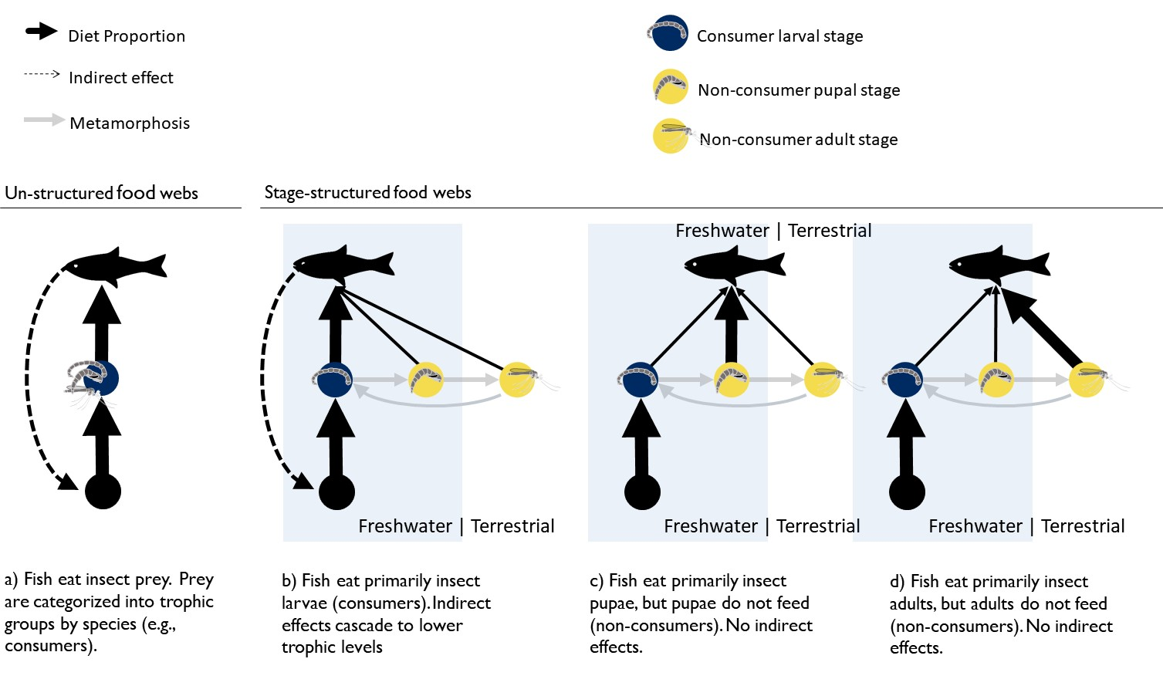

**Figure 2**

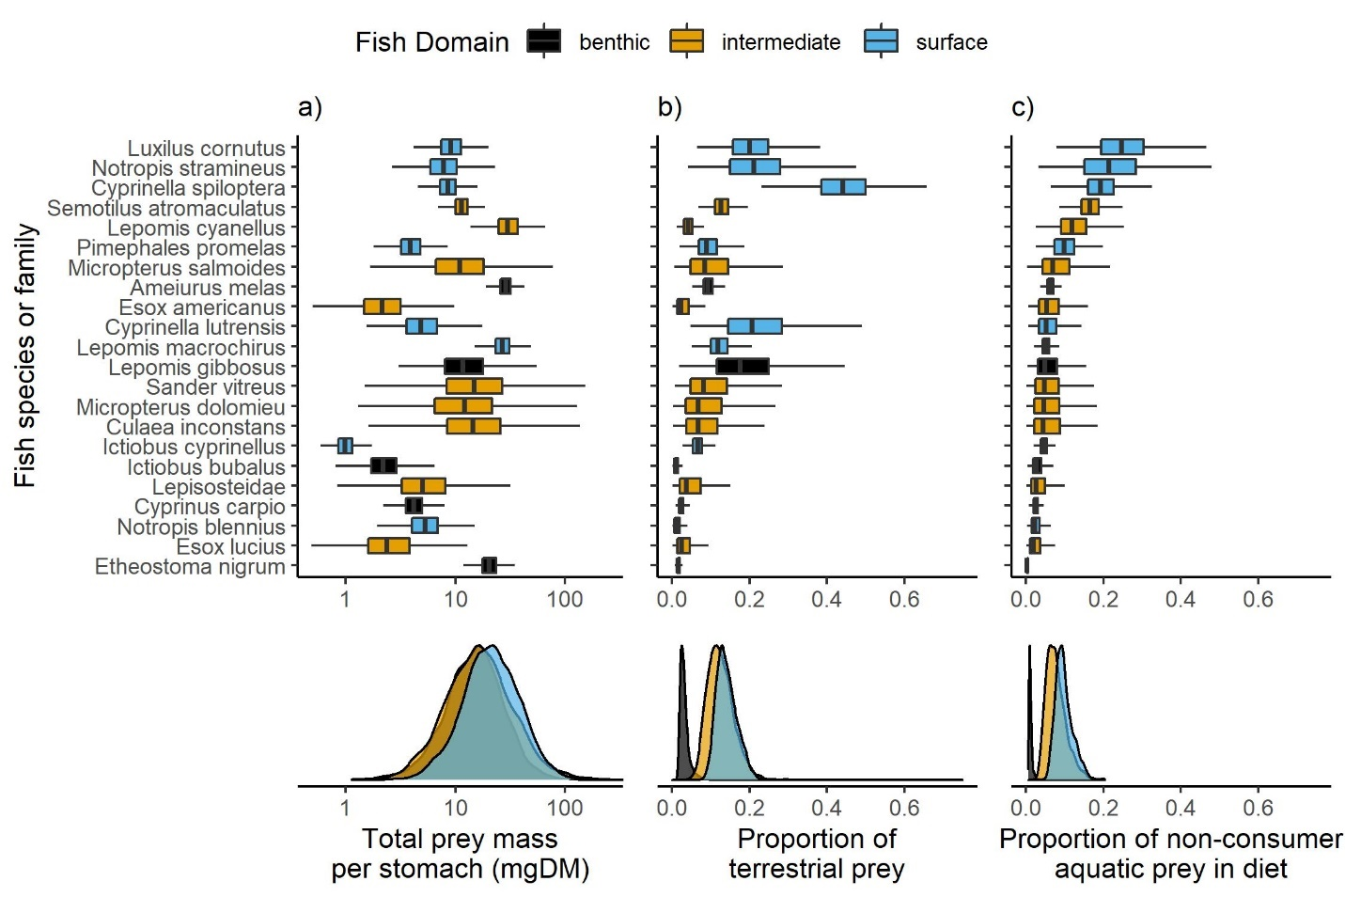

**Figure 3**

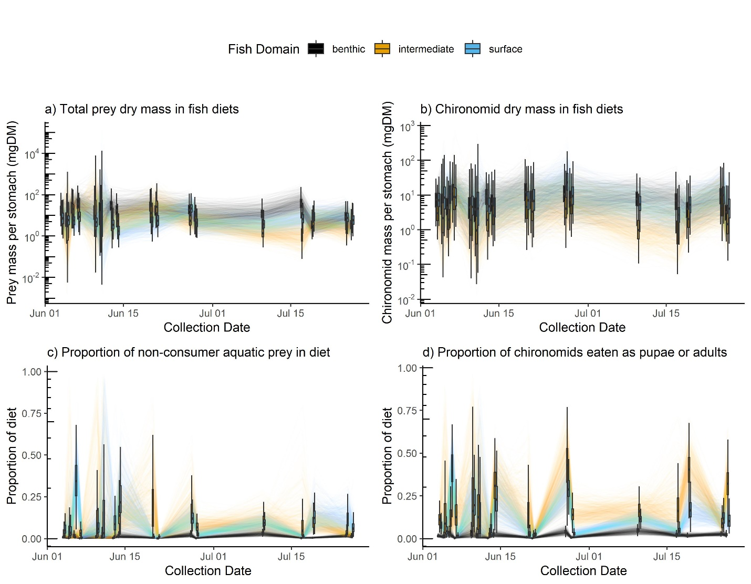

**Figure 4**

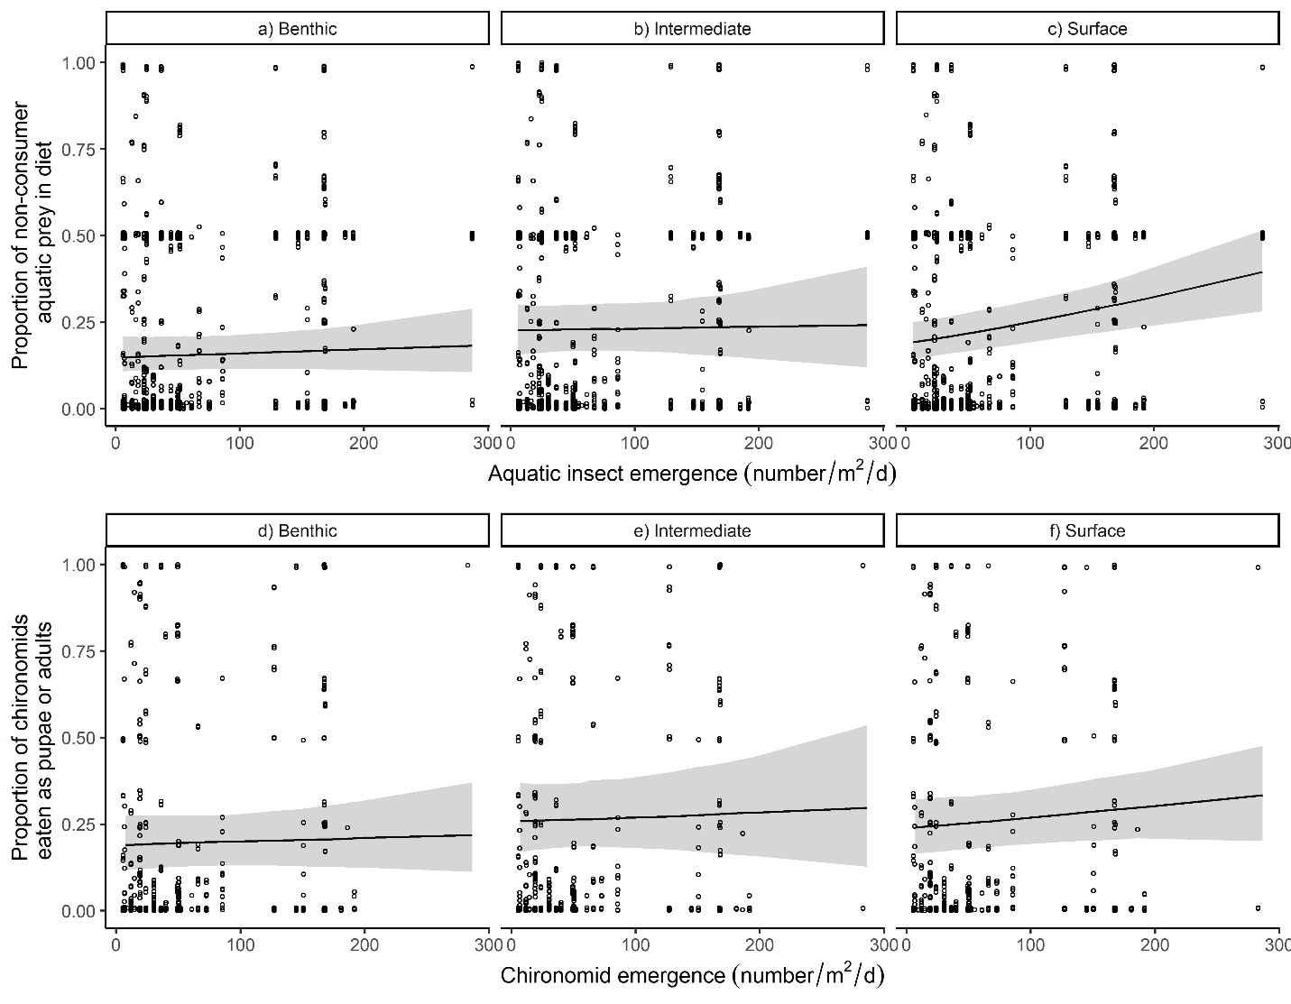

**Supplemental Information**

|  |  |  |  |  |  |  |
| --- | --- | --- | --- | --- | --- | --- |
| **Table S1**: Proportion of chironomid life-stages in fish diets by abundance. Values summarize the posterior distribution averaged over 17 collection events. | | | | | | |
| Prey Stage | Fish Domain | Mean | SD | 2.5% | 50% | 97.5% |
| Larvae | Benthic | 0.91 | 0.10 | 0.01 | 0.06 | 0.37 |
| Larvae | Intermediate | 0.71 | 0.17 | 0.29 | 0.74 | 0.95 |
| Larvae | Surface | 0.78 | 0.14 | 0.47 | 0.81 | 0.97 |
| Larvae | All Fish | 0.80 | 0.12 | 0.51 | 0.82 | 0.96 |
| Pupae | Benthic | 0.05 | 0.07 | 0.002 | 0.03 | 0.27 |
| Pupae | Intermediate | 0.22 | 0.15 | 0.02 | 0.20 | 0.57 |
| Pupae | Surface | 0.06 | 0.06 | 0.004 | 0.04 | 0.21 |
| Pupae | All Fish | 0.11 | 0.08 | 0.01 | 0.09 | 0.30 |
| Adults | Benthic | 0.04 | 0.05 | 0.001 | 0.02 | 0.17 |
| Adults | Intermediate | 0.08 | 0.09 | 0.003 | 0.05 | 0.34 |
| Adults | Surface | 0.16 | 0.12 | 0.02 | 0.14 | 0.44 |
| Adults | All Fish | 0.09 | 0.08 | 0.01 | 0.07 | 0.29 |

**Model Checking**

We determined prior values using prior predictive checks (Wesner and Pomeranz 2021). Briefly, we simulated the proportion of diets that were terrestrial or the proportion of aquatic diets that were non-consumers using only the prior distributions (Figure S2). We then visually compared that estimate to the posterior (Figure S2). The contrast in estimates shows both whether priors were reasonable and how much information was learned from the data. The result in Figure S2 shows reasonable but wide estimates from the prior along with narrow estimates of the posterior distribution.

In addition, we performed posterior predictive checks to determine whether and how the models mis-fit the data using the *pp_check()* function in *brms*. We compared two simulations for the two main models: 1) Model simulated means relative to data means (Figure S3a,b), and 2) histograms of model-simulated data relative to a histogram of the raw data (Figure S3c,d). Large mismatches in these comparisons indicate that the model fails to capture an aspect of the data-generating process. In general, the model simulations can recapture data summaries (Figure S3). One aspect that the models do not capture is the relatively high number of zeros in the aquatic vs terrestrial dataset. In exploratory analyses, we attempted to account for this with different likelihoods, including a hurdle gamma and by fitting the model to proportions with a zero inflated beta distribution. Neither alternative performed better in posterior predictive checks, so we chose the gamma model.

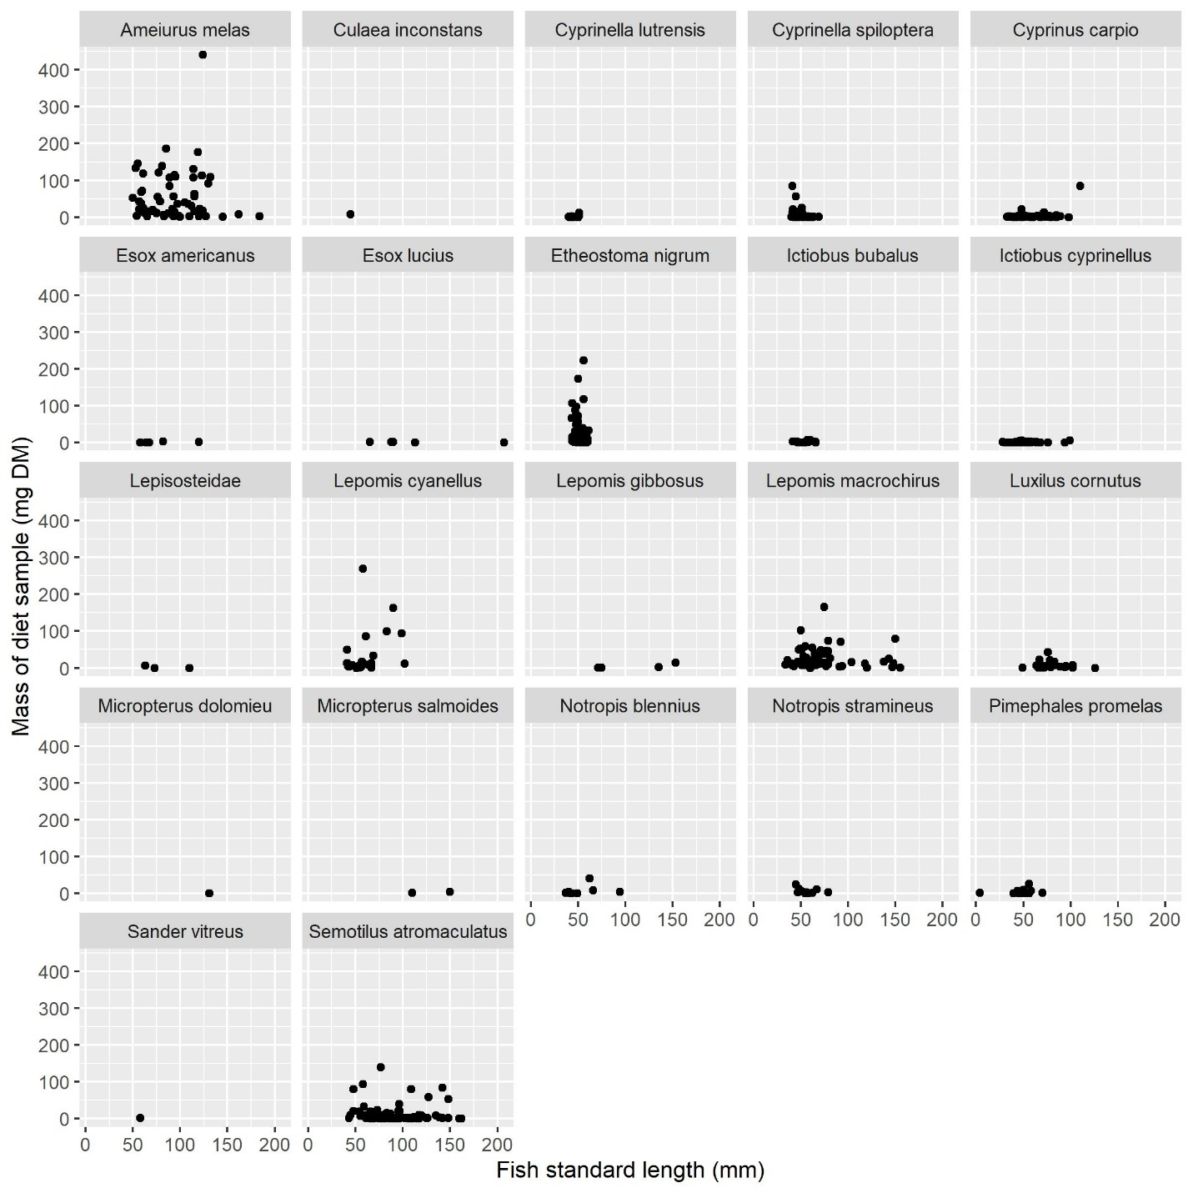

**Fig. S1.** Plots of raw data showing no relationship between fish size (length) and the mass of prey in the diet sample. For this reason, we did not correct diet samples by fish length.

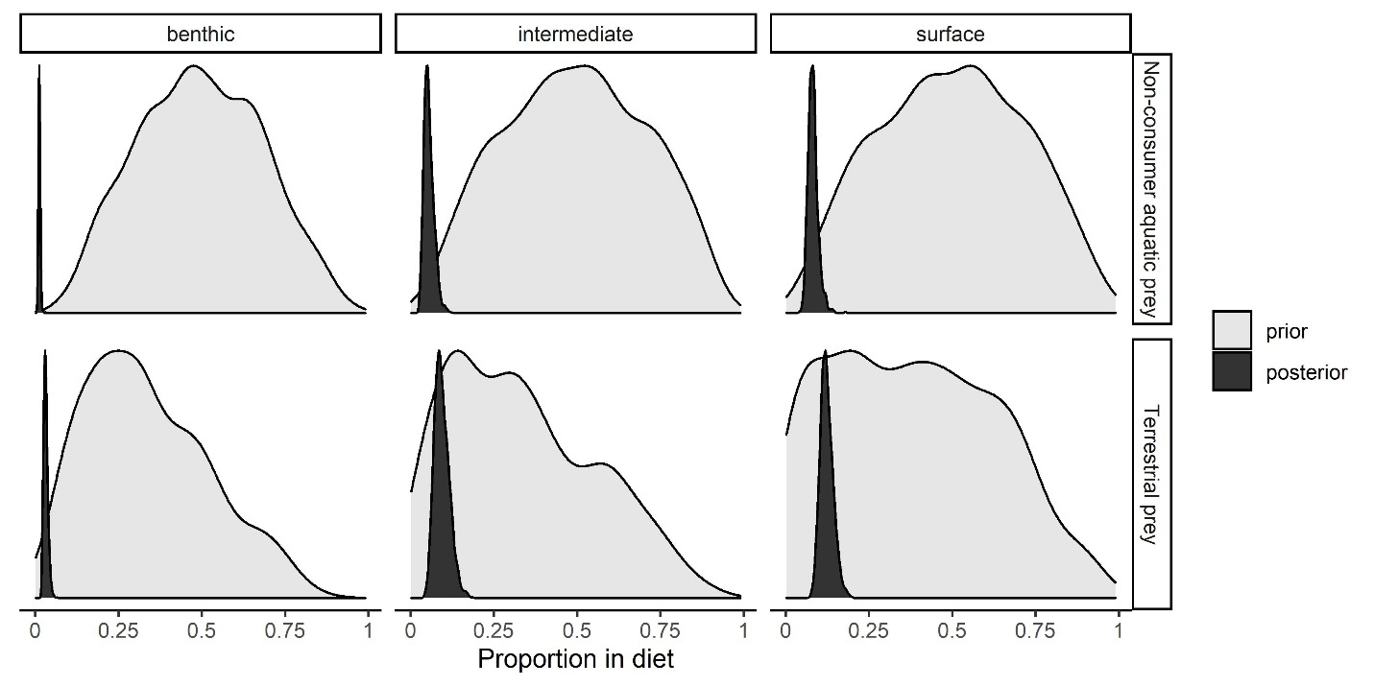

**Fig. S2.** Comparison of the prior and posterior predictions of the proportion of aquatic prey that were non-consumers (top row) and the proportion of total prey that were terrestrial. All proportions are derived from dry mass (mg).

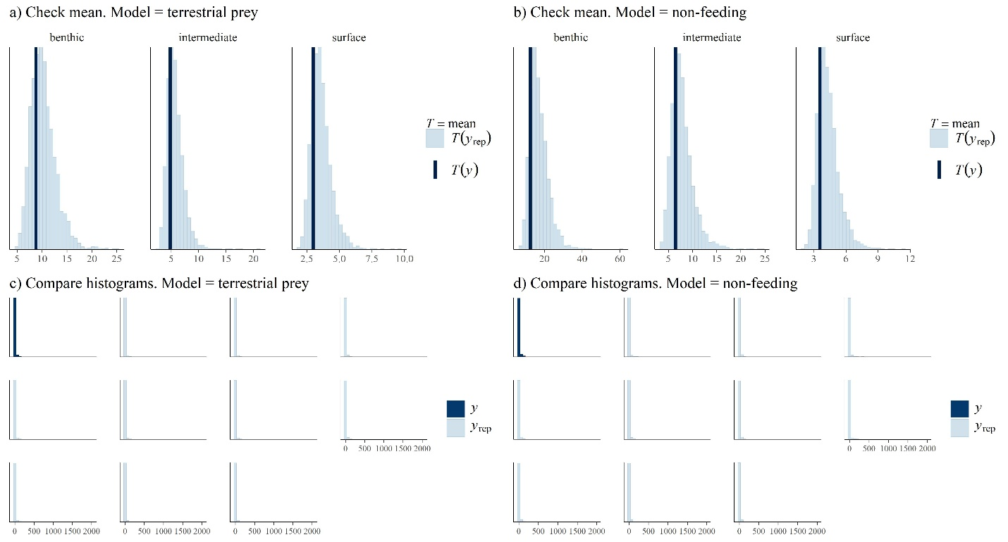

**Fig. S3.** Checking model fits. Posterior predictive checks of models of aquatic vs terrestrial prey (“terrestrial prey”) and the proportion of aquatic prey that are non-consumer (“non-feeding”). The top panels (a,b) show each model’s prediction of mean prey mass (*T*(*yrep*)) relative to the data (*T*(*y*)). The bottom panels (c,d) compare data distributions of the raw data (*y*) relative to ten datasets simulated from the posterior distribution. Similarities in these distributions indicate that the model is a good fit.

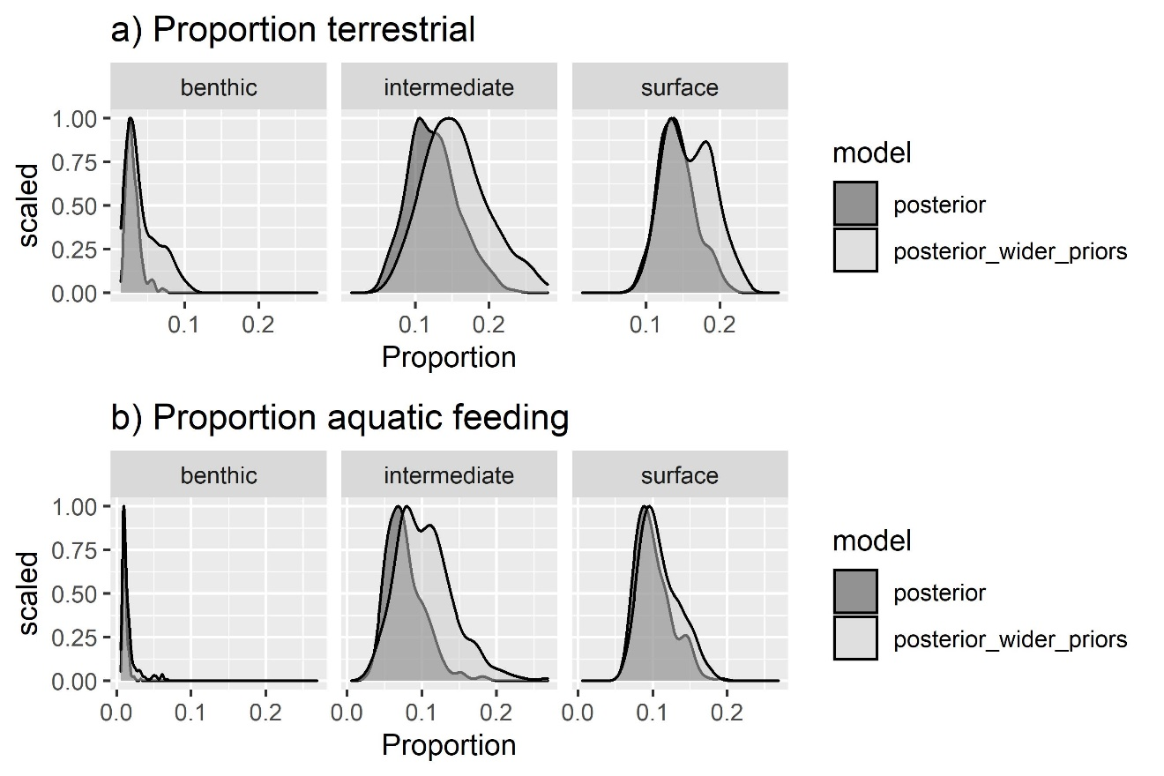

**Fig. S4.** Prior sensitivity analysis of the fraction of terrestrial prey and the proportion of aquatic prey that are non-feeders. Dark gray shows the posterior estimates for the main models in the manuscript. Lighter gray (“posterior_wider_priors”) shows posterior estimates with wider priors in which the sd of the intercept and betas are 2X wider than the main model.

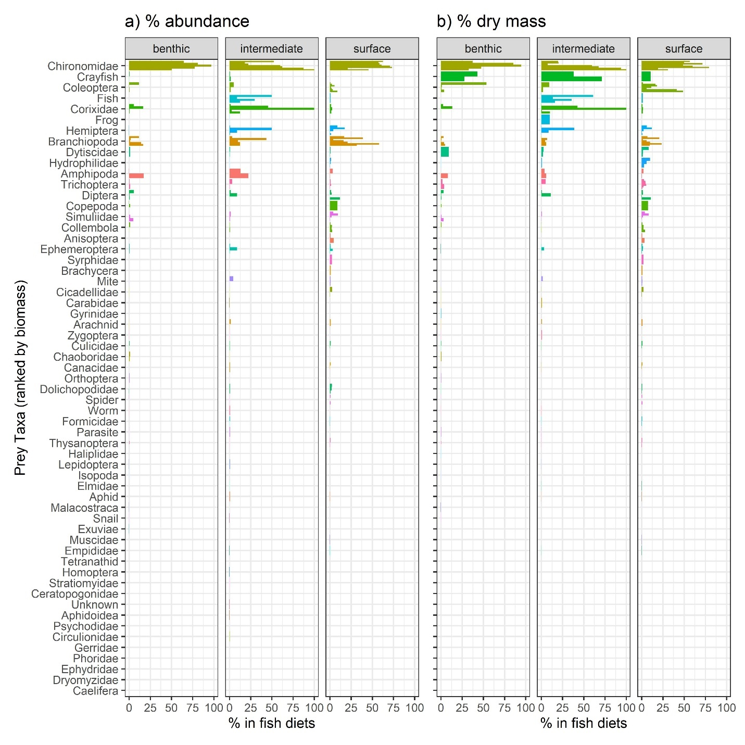

**Fig. S5.** Raw proportion of prey taxa in fish diets by abundance (a) and dry mass (b). Each bar represents a different fish species in one of three foraging domains.

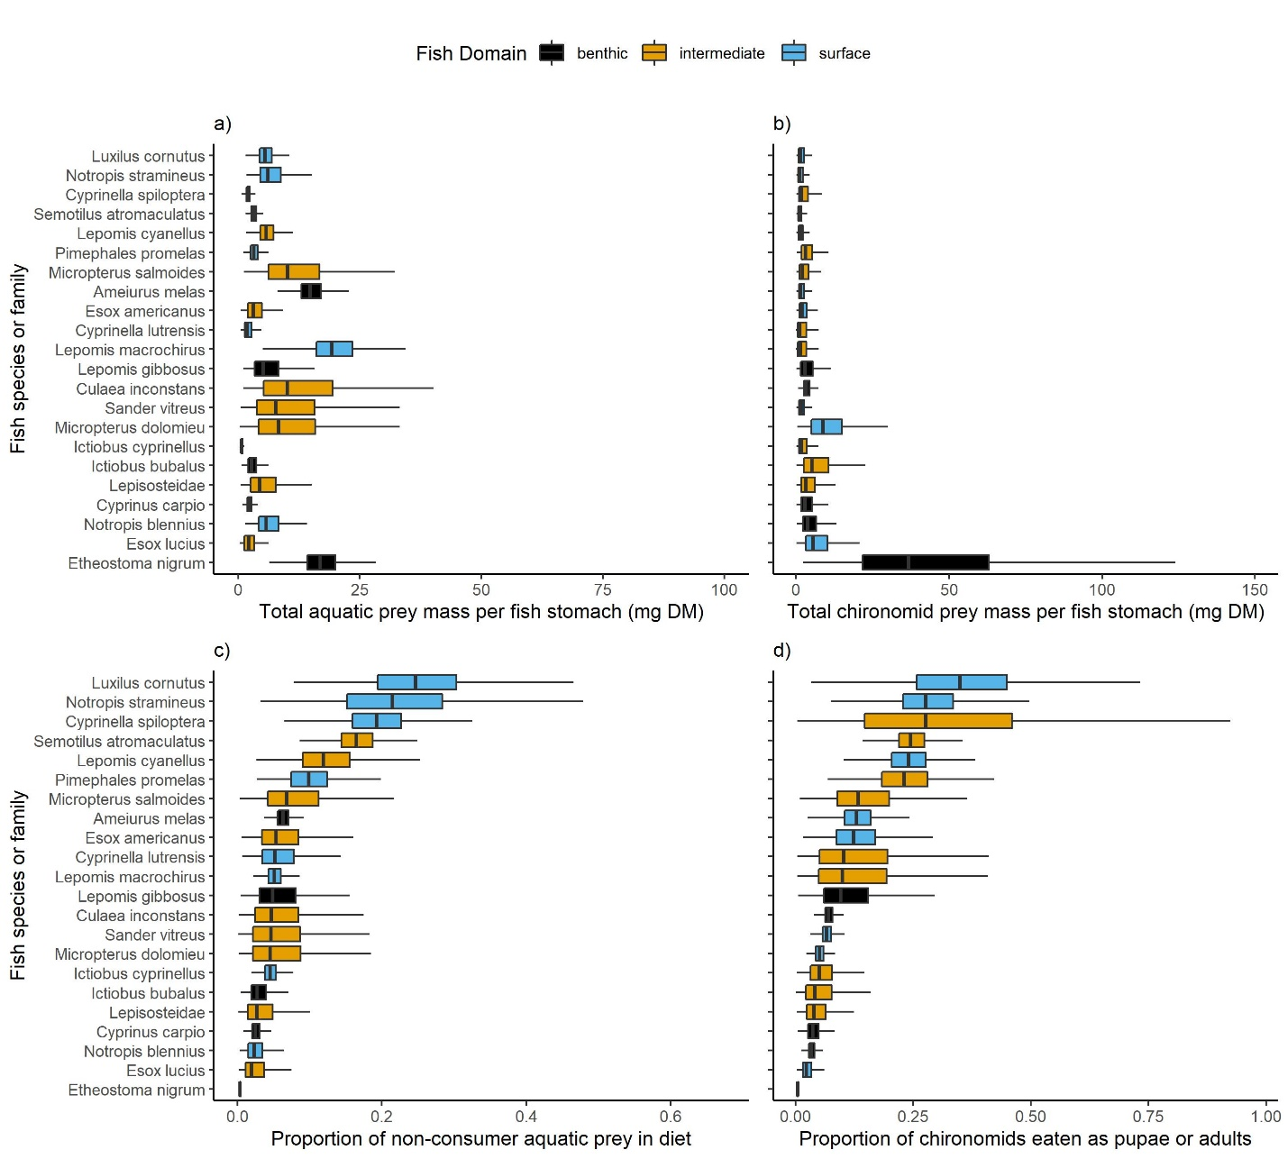

**Fig. S6.** Prey mass (mg DM) per stomach of each fish species for a) total aquatic prey and b) total chironomid prey. The bottom row shows the proportion of all aquatic prey that were eaten as c) non-consumers or d) the proportion of all chironomids that were eaten as adults or pupae. Boxplots show the posterior distribution for each fish species, including the median and interquartile range with lines ranging from the lowest to highest 1.5% posterior quantiles. All panels are sorted by the median proportion of non-consumers in diets.